**Lab 09**

**Keypad interfacing (port multiplexing)**

**Objective:**

* To Learn how to connect a keypad to 8051 micro-controller

**Components needed for this lab:**

* Keil µVision IDE
* Proteus Software
* 8051 Micro-controller

**8051 Micro-controller:**

* 8051 have 40 pins dedicated for various functions such as I/O, -RD, -WR, address, data, and interrupts.
* The 8051 has an on-chip oscillator but requires an external clock to run it. A quartz crystal oscillator is connected to inputs XTAL1 (pin19) and XTAL2 (pin18). The quartz crystal oscillator also needs two capacitors of 30 pF value

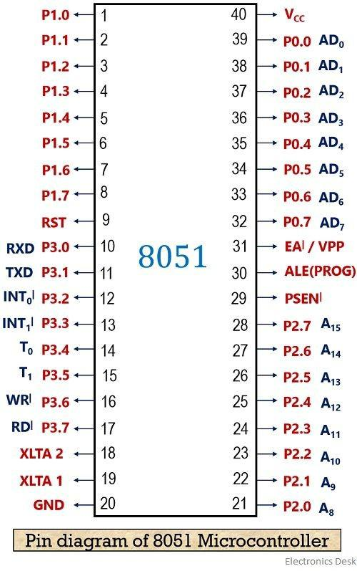

Fig 01: 8051 Pin Diagram

**Tasks:**

**1: Run the program given in the lecture**

#include <stdio.h>

#include <reg51.h>

sbit RowA = P1^0;

sbit RowB = P1^1;

sbit RowC = P1^2;

sbit RowD = P1^3;

sbit C1 = P1^4;

sbit C2 = P1^5;

sbit C3 = P1^6;

sbit C4 = P1^7;

unsigned int value;

unsigned int bcd;

void READ_SWITCHES(void);

int main(void){

while(1)

{

READ_SWITCHES();

P3 = value;

P2 = bcd;

}

}

void READ_SWITCHES(void){

RowA = 0;

RowB = 1;

RowC = 1;

RowD = 1;

if(C1 == 0) {bcd = 1; value = 0xF9;}

if(C2 == 0) {bcd = 2; value = 0xA4;}

if(C3 == 0) {bcd = 3; value = 0xB0;}

RowA = 1;

RowB = 0;

RowC = 1;

RowD = 1;

if(C1 == 0) { bcd = 4; value = 0x99;}

if(C2 == 0) { bcd = 5; value = 0x92;}

if(C3 == 0) { bcd = 6; value = 0x82;}

}

8051 C Code to show 15 ms delay using timer0

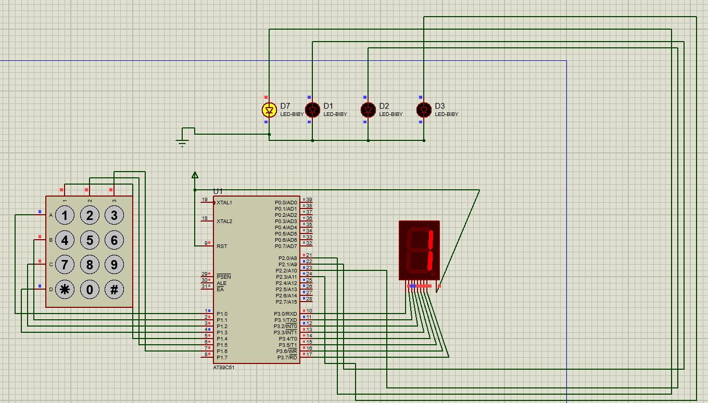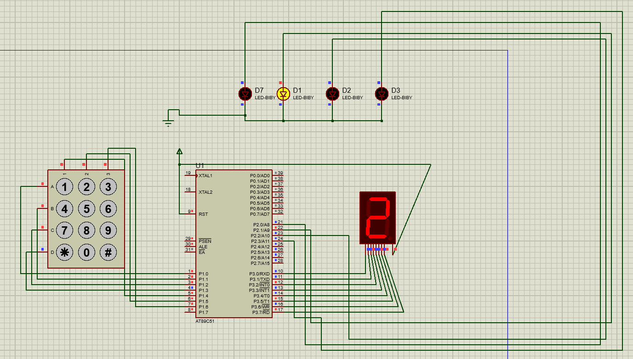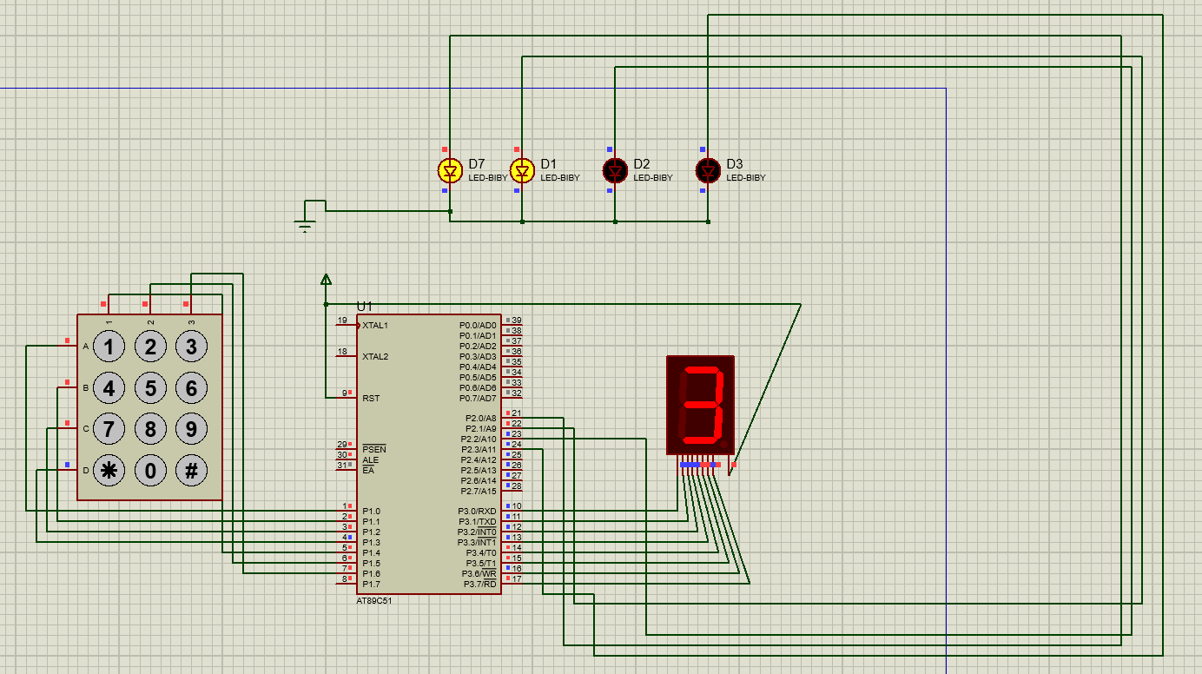

_________________________________________________________________________________________________________

**2: Display Numbers from 1 to 9 on the seven segment display and ON**

**the corresponding LED’s attached with P1**

#include <stdio.h>

#include <reg51.h>

sbit RowA = P1^0;

sbit RowB = P1^1;

sbit RowC = P1^2;

sbit RowD = P1^3;

sbit C1 = P1^4;

sbit C2 = P1^5;

sbit C3 = P1^6;

sbit C4 = P1^7;

unsigned int value;

unsigned int bcd;

void READ_SWITCHES(void);

int main(void){

while(1)

{

READ_SWITCHES();

P3 = value;

P2 = bcd;

}

}

void READ_SWITCHES(void){

RowA = 0;

RowB = 1;

RowC = 1;

RowD = 1;

if(C1 == 0) {bcd = 1; value = 0xF9;}

if(C2 == 0) {bcd = 2; value = 0xA4;}

if(C3 == 0) {bcd = 3; value = 0xB0;}

RowA = 1;

RowB = 0;

RowC = 1;

RowD = 1;

if(C1 == 0) { bcd = 4; value = 0x99;}

if(C2 == 0) { bcd = 5; value = 0x92;}

if(C3 == 0) { bcd = 6; value = 0x82;}

8051 C Code to show 50 ms delay using timer0

RowA = 1;

RowB = 1;

RowC = 0;

RowD = 1;

if(C1 == 0) { bcd = 7; value = 0xF8;}

if(C2 == 0) { bcd = 8; value = 0x80;}

if(C3 == 0) { bcd = 9; value = 0x98;}

RowA = 1;

RowB = 1;

RowC = 1;

RowD = 0;

if(C1 == 0) { bcd = 0Xff; value = 0xC0;}

if(C2 == 0) { bcd = 0; value = 0xFF;}

if(C3 == 0) { bcd = 0xff; value = 0xFF; }

}



